Program 2: Working with Maven: Creating a Maven Project, Understanding the POM File, Dependency Management and Plugins
Aim
To create a Maven project using IntelliJ IDEA, execute a Selenium-based login automation program,
publish static web pages using GitHub Pages, test the hosted webpage using TestNG, and generate an executable JAR file.
- Create Maven project
- Add dependencies
- Automate login using Selenium
- Host website using GitHub Pages
- Test webpage using TestNG
- Build project using Maven

Software / Tools Required
- IntelliJ IDEA
- JDK recent version or above
- Apache Maven
- Google Chrome Browser
- Git & GitHub Account

Task 1: Creating Maven Project and Login Automation Test
Step 1: Create Maven Project
- Open IntelliJ IDEA
- Click FileàNewàProject
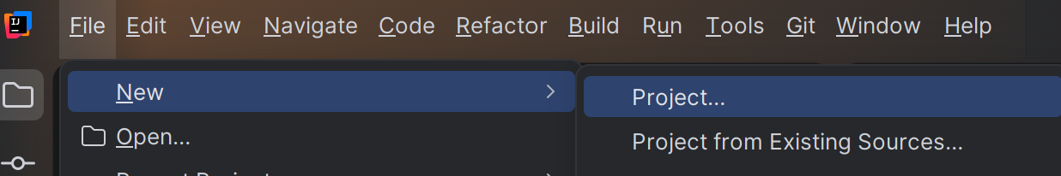
- Select Java and Maven
- Give a Project Name
- In Advanced Settings, verify:
GroupId: org.example
ArtifactId: selenium-maven Click Finish
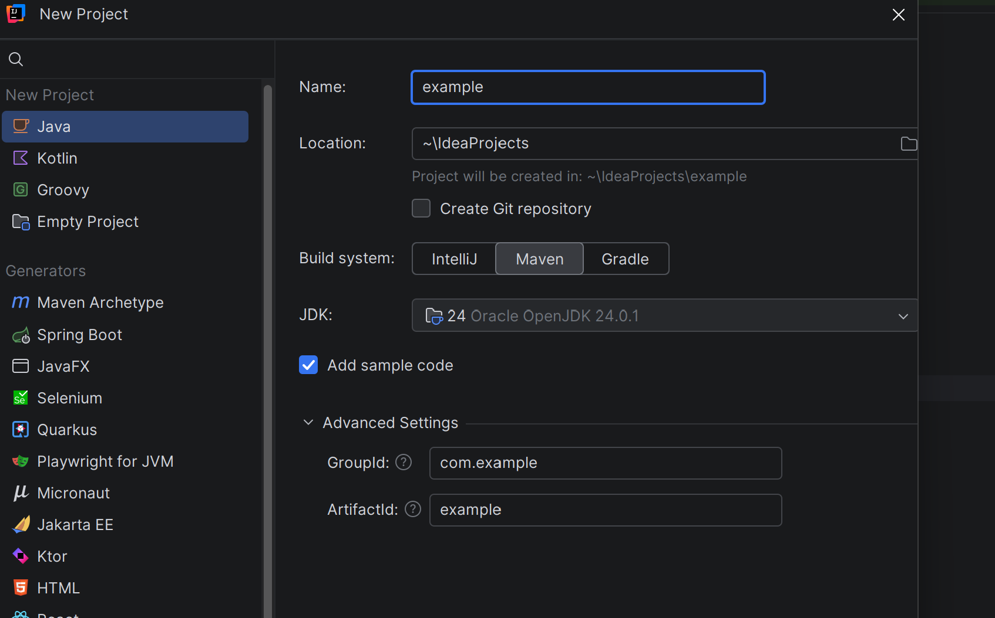

Task 2: Adding Selenium Dependency
Open pom.xml and paste the following code
<project xmlns="http://maven.apache.org/POM/4.0.0"
xmlns:xsi="http://www.w3.org/2001/XMLSchema-instance"
xsi:schemaLocation="http://maven.apache.org/POM/4.0.0
http://maven.apache.org/xsd/maven-4.0.0.xsd">

<modelVersion>4.0.0</modelVersion>

<groupId>org.example</groupId>
<artifactId>selenium-maven</artifactId>
<version>1.0-SNAPSHOT</version>

<properties>
<maven.compiler.source>11</maven.compiler.source>
<maven.compiler.target>11</maven.compiler.target>
</properties>
</project>
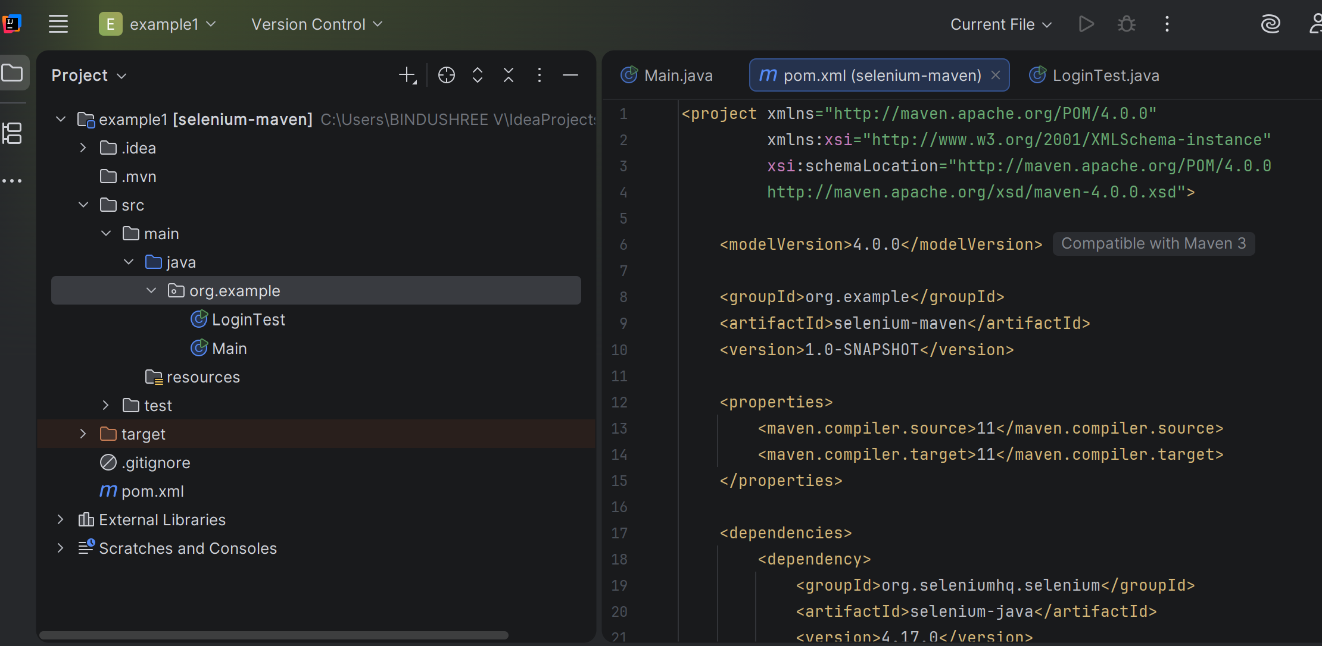
Reload Maven
- Click Load Maven Changesàright side of the intellij window
- OR run: mvn clean install
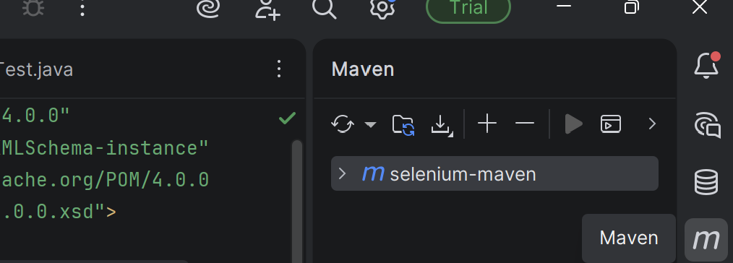yu

Or
Right click on your projectà click openinàterminal, if not opening
File → Settings → Tools → Terminal
C:\Windows\System32\cmd.exe
At the Botton of the IDE you can see terminal
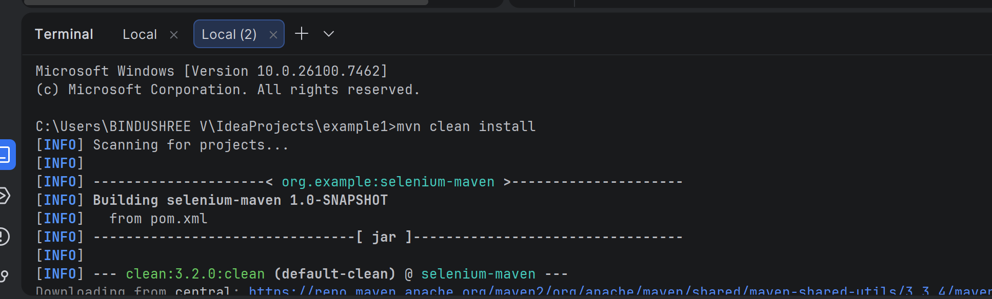
Task 3: Creating Login Automation Program
Steps
- src → main → java → org → example
- Create a Java class LoginTest
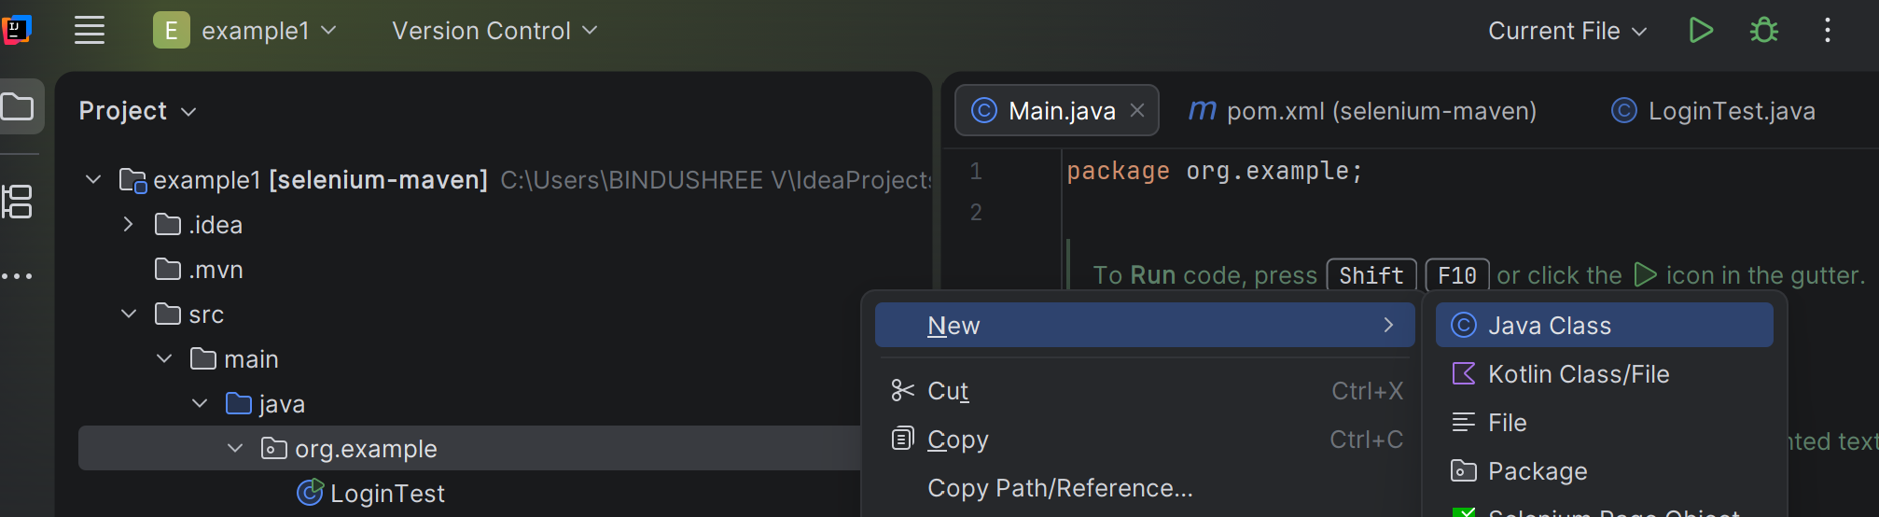

package org.example;

import org.openqa.selenium.By;
import org.openqa.selenium.WebDriver;
import org.openqa.selenium.chrome.ChromeDriver;

public class LoginTest {
public static void main(String[] args) throws InterruptedException {

WebDriver driver = new ChromeDriver();
driver.get("https://www.saucedemo.com/");
driver.manage().window().maximize();

Thread.sleep(2000);
driver.findElement(By.id("user-name"))
.sendKeys("standard_user");

Thread.sleep(2000);
driver.findElement(By.id("password"))
.sendKeys("secret_sauce");

Thread.sleep(2000);
driver.findElement(By.id("login-button"))
.click();

Thread.sleep(2000);
driver.quit();
}
}

Run the Program
Click Run ▶
Chrome opens
Login is automated
Browser closes

Task 4: Adding Static Website Files

Copy the following files into: src/main/resources
- index.html
- style.css
- logo.png

Task 5: Creating Docs Folder Using Maven Plugin
//Add the below code into pom.xml after dependency tags

<build>
<plugins>
<plugin>
<groupId>org.apache.maven.plugins</groupId>
<artifactId>maven-resources-plugin</artifactId>
<version>3.2.0</version>
<executions>
<execution>
<phase>prepare-package</phase>
<goals>
<goal>copy-resources</goal>
</goals>
<configuration>
<outputDirectory>${project.basedir}/docs</outputDirectory>
<resources>
<resource>
<directory>src/main/resources</directory>
<includes>
<include>*/</include>
</includes>
</resource>
</resources>
</configuration>
</execution>
</executions>
</plugin>
</plugins>
</build>

mvn clean install
docs/ folder is created.

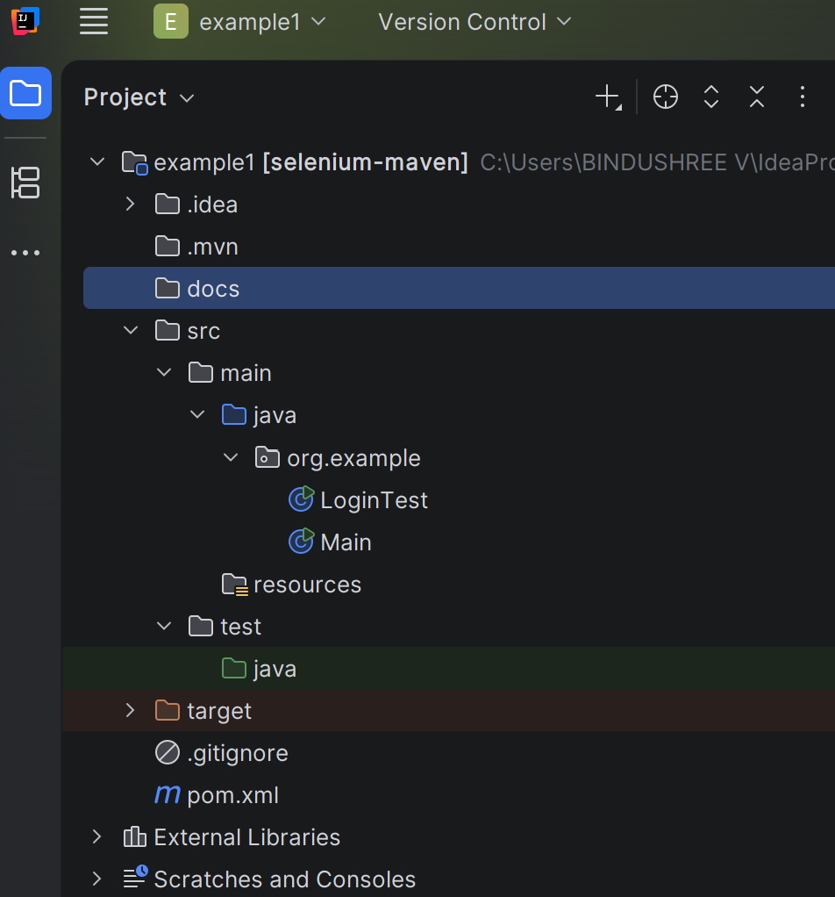

Task 6: Publishing Website Using GitHub Pages
Steps
- Open project folder → Git Bash
- Execute:

git init
git add .
git commit -m "Initial commit"

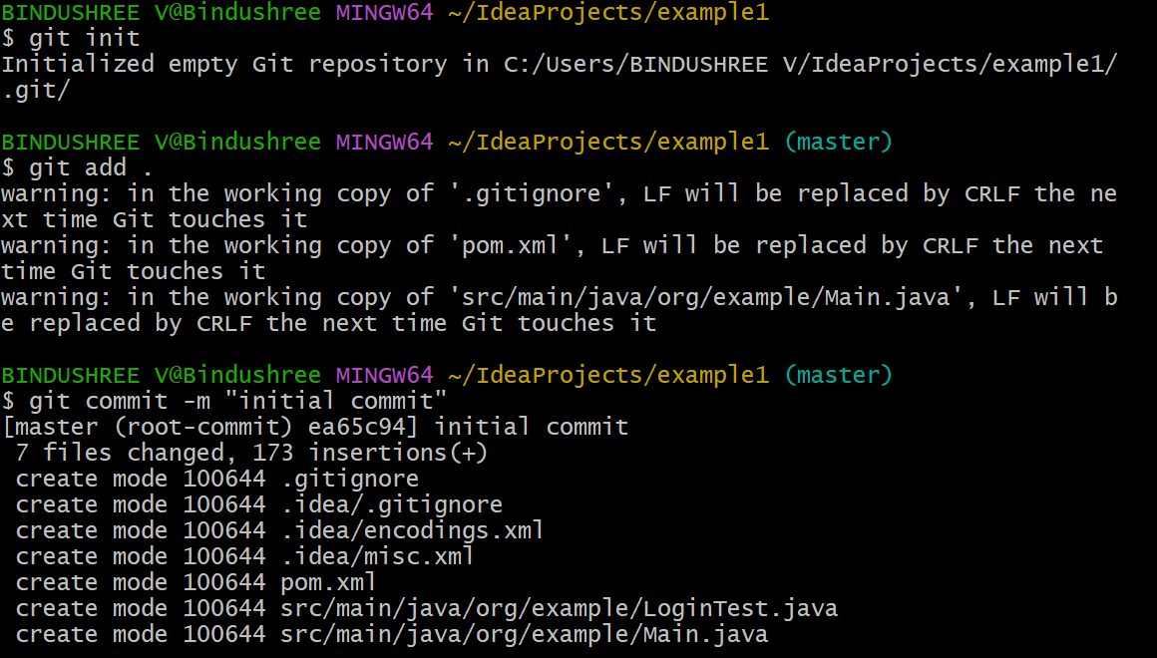
- Create a new GitHub repository
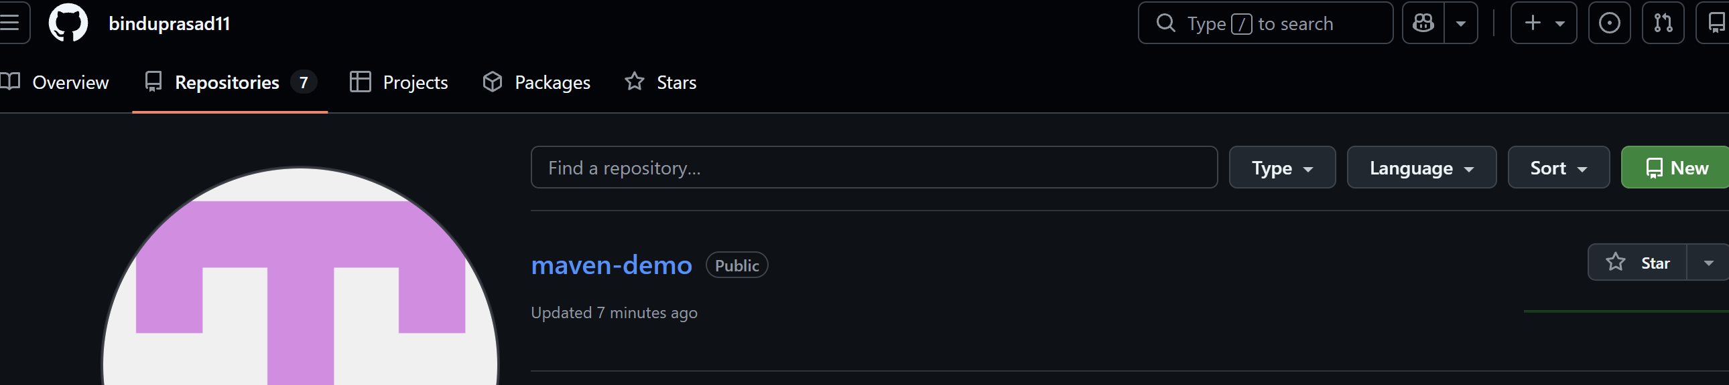
Then execute:
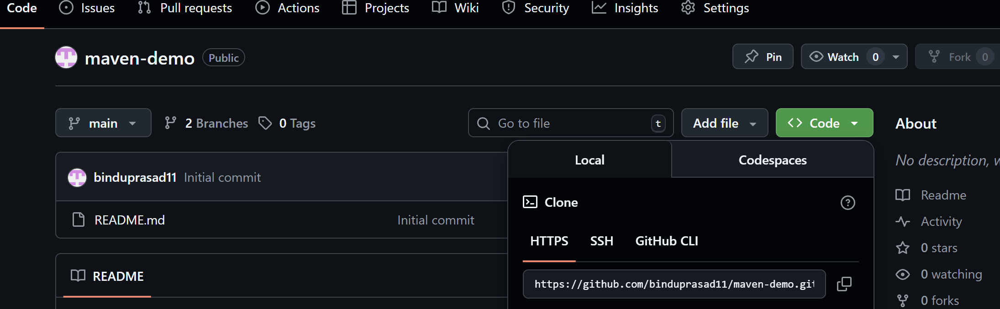

git remote add origin <repository-url: go to the newly created repository in the github and copy its url>
git push -u origin master

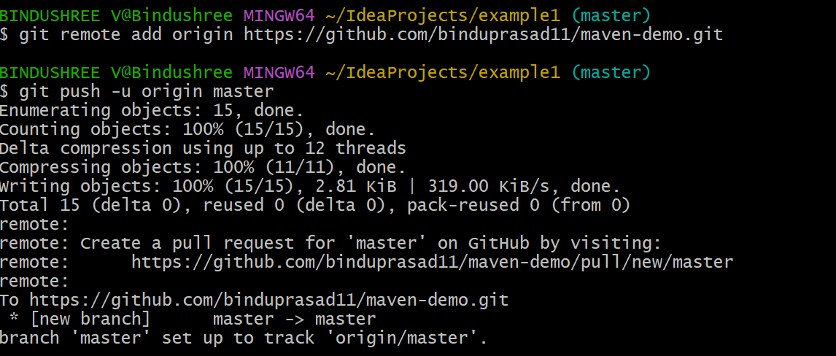
- GitHub → Settings → Pages
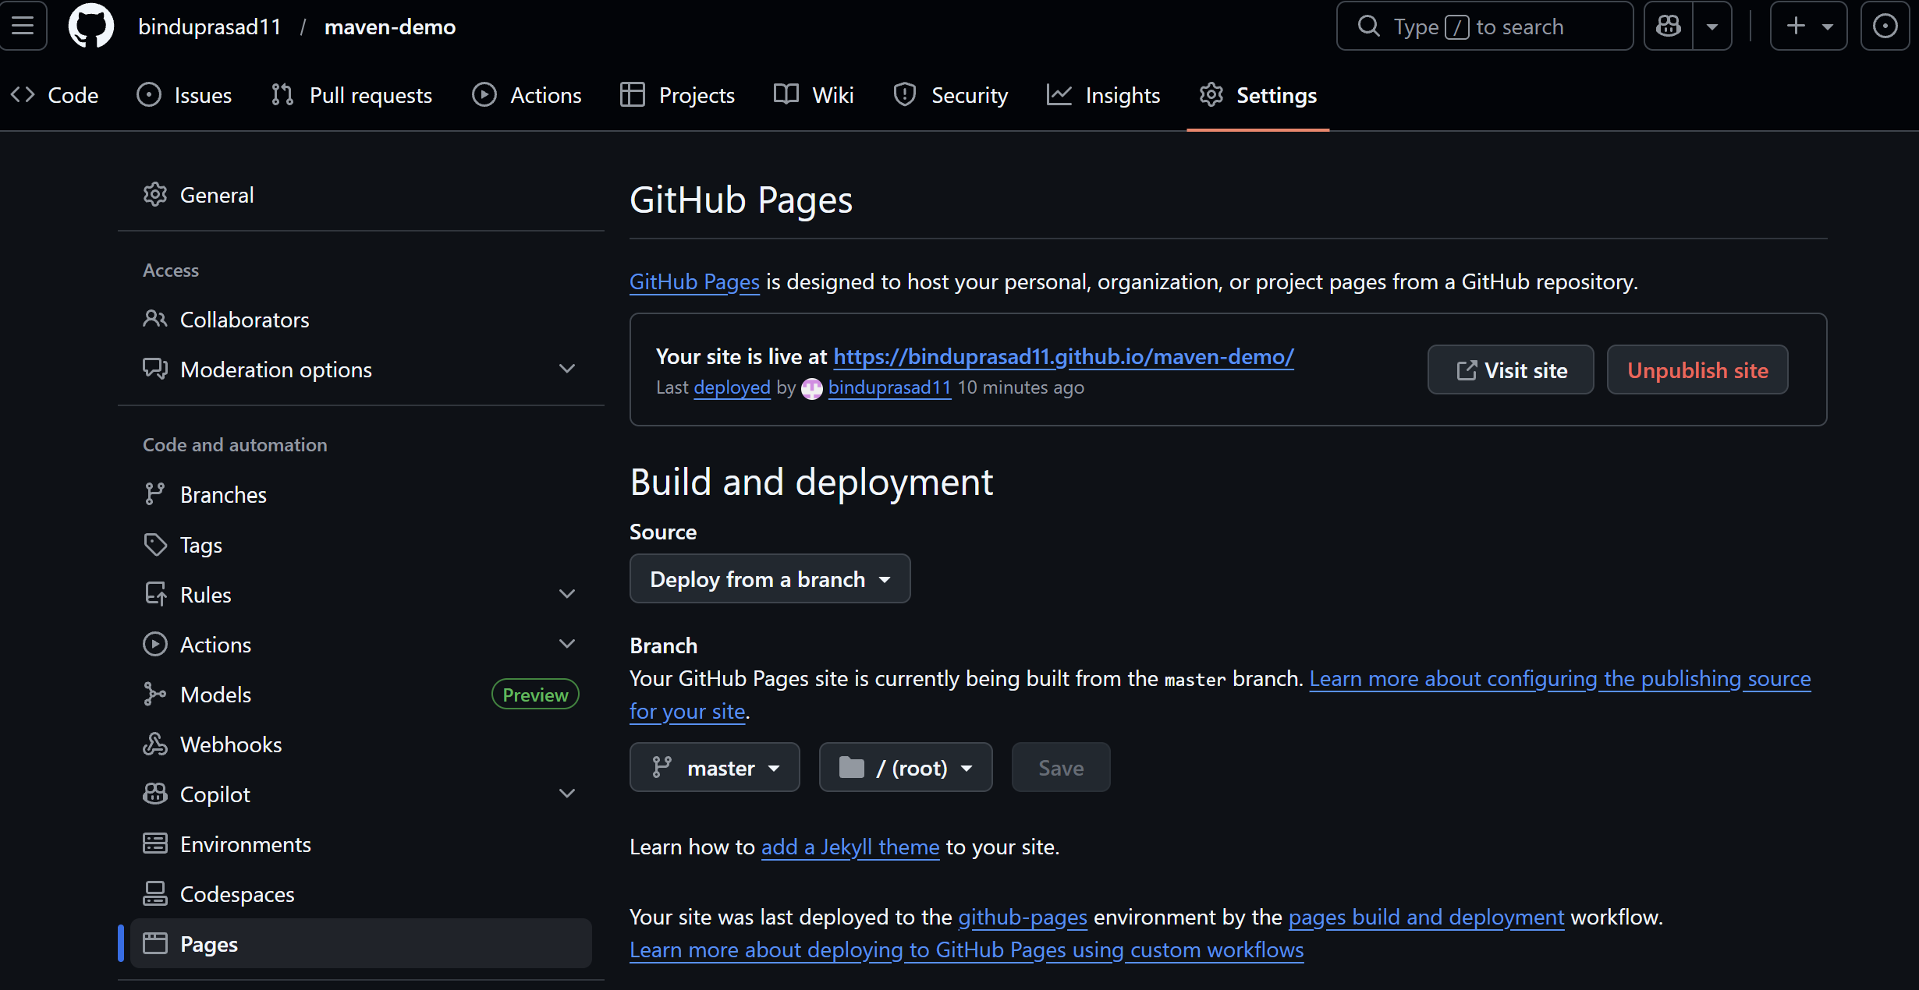
- Select:
  - Branch: master
  - Folder: /docs
- Save and wait 1–2 minutes
Website is published successfully.

Task 7: Webpage Testing Using TestNG
Create WebpageTest.java
Location: src/test/java/org/test

package org.example;

import org.openqa.selenium.WebDriver;
import org.openqa.selenium.chrome.ChromeDriver;
import org.testng.Assert;
import org.testng.annotations.AfterTest;
import org.testng.annotations.BeforeTest;
import org.testng.annotations.Test;

public class WebpageTest {

WebDriver driver;

@BeforeTest
public void openBrowser() throws InterruptedException {
driver = new ChromeDriver();
driver.manage().window().maximize();
Thread.sleep(2000);
driver.get("YOUR_GITHUB_PAGES_URL");
}

@Test
public void titleValidationTest() {
String actualTitle = driver.getTitle();
String expectedTitle = "Tripillar Solutions";
Assert.assertEquals(actualTitle, expectedTitle);
}

@AfterTest
public void closeBrowser() throws InterruptedException {
Thread.sleep(1000);
driver.quit();
}
}
After adding this, you should one more dependency to the pom file
<dependency>
<groupId>org.testng</groupId>
<artifactId>testng</artifactId>
<version>7.9.0</version>
<scope>test</scope>
</dependency>
Then reload the maven to reflect changes

Task 8: Creating Executable JAR File
Add Maven JAR Plugin
<plugin>
<groupId>org.apache.maven.plugins</groupId>
<artifactId>maven-jar-plugin</artifactId>
<version>3.1.0</version>
<configuration>
<archive>
<manifestEntries>
<Main-Class>org.example.Main</Main-Class>
</manifestEntries>
</archive>
</configuration>
</plugin>

Task 9: Creating Main Class
package org.example;

public class Main {
public static void main(String[] args) {
System.out.println("Hello from Maven!");
}
}
mvn clean package
JAR file created in target/ folder.

VIVA QUESTIONS – MAVEN
Definition
Maven is a build automation and dependency management tool used for Java projects.
Why Maven Is Needed
In Java projects, we need:
- External libraries (Selenium, TestNG)
- Proper project structure
- Easy build and execution
Without Maven:
- We manually download JAR files
- We manually add them to the project
- Errors occur frequently
Maven automates all this work.
What Maven Does Automatically
- Downloads required libraries from the internet
- Compiles Java code
- Runs tests
- Packages the project (JAR file)
- Executes plugins

What Is pom.xml?
Definition
pom.xml (Project Object Model) is the configuration file of a Maven project.
Why It Is Important
It tells Maven:
- Project name and version
- Java version
- Which libraries to download
- Which plugins to execute
Without pom.xml, Maven cannot work.
What Is Selenium?
Definition
Selenium is an automation testing tool used to control web browsers automatically.
What Selenium Can Do
- Open a browser
- Open a website
- Type text
- Click buttons
- Validate webpages
Selenium behaves like a human user, but works automatically.
What Is WebDriver?
Definition
WebDriver is an interface provided by Selenium that acts as a controller for web browsers.
Why WebDriver Is Needed
Java cannot directly control a browser.
So Selenium provides WebDriver, which:
- Acts as a bridge between Java and browser
- Sends commands like open, click, type
Think of WebDriver as a remote control for the browser.

What Is ChromeDriver?
Definition
ChromeDriver is a browser-specific driver used to control the Google Chrome browser.
Why It Is Required
Each browser needs its own driver:
- Chrome → ChromeDriver
- Firefox → GeckoDriver
- Edge → EdgeDriver
ChromeDriver understands Chrome’s internal language.

Relationship Between WebDriver and ChromeDriver
WebDriver driver = new ChromeDriver();
This means:
- Chrome browser is opened
- WebDriver controls it
What Are Dependencies?
Definition
Dependencies are external libraries required by a project.
Examples:
- Selenium
- TestNG
Maven downloads dependencies automatically from Maven Central Repository.
What Is Selenium Dependency?
<dependency>
<groupId>org.seleniumhq.selenium</groupId>
<artifactId>selenium-java</artifactId>
<version>4.17.0</version>
</dependency>
This dependency provides
- WebDriver
- ChromeDriver
- By
- Browser automation methods
Without it, Selenium classes cannot be used.
What Is TestNG?
Definition
TestNG is a testing framework used to validate applications.
Why TestNG Is Used
- Organizes test cases
- Provides annotations
- Generates reports
- Supports assertions

What is a dependency in Maven?
Answer:
A dependency is an external library required by a project to run or compile successfully.

How does Maven download dependencies?
Answer:
Maven downloads dependencies automatically from online repositories when a build command is executed.

Where does Maven store downloaded dependencies?
Answer:
Maven stores dependencies in the local repository located at .m2/repository.

What is groupId?
Answer:
groupId represents the organization or company name of the project.

What is artifactId?
Answer:
artifactId is the name of the project or the generated output file.

What is version in Maven?
Answer:
It specifies the version of the project.

What is a Maven repository?
Answer:
A Maven repository is a location where project dependencies and plugins are stored.

Types of Maven repositories?
Answer:
- Local repository
- Central repository
- Remote repository

What is Maven lifecycle?
Answer:
Maven lifecycle is a sequence of phases used to build and manage a project.

Name the Maven lifecycle phases.
Answer:
Validate, Compile, Test, Package, Verify, Install, Deploy.

What happens when we run mvn install?
Answer:
Maven compiles the code, runs tests, creates a package, and installs it into the local repository.
What is a Maven plugin?
Answer:
A plugin is used to perform specific tasks like compiling code, running tests, or packaging the project.

Give an example of a Maven plugin.
Answer:
maven-compiler-plugin.

What is dependency scope?
Answer:
Dependency scope defines when a dependency is required during the build process.

Types of dependency scopes?
Answer:
- compile
- test
- provided
- runtime

What is mvn clean?
Answer:
It deletes the previous build files from the target folder.

What is the output of mvn package?
Answer:
It generates a JAR or WAR file inside the target directory.

